CO2 Sensor data Application Design Document

**Version : 0.81.0.1**

**Date : 10-08-2020**

**Status : ValidReviewed**

**Author :** **JesinAllianz Code Collaborative Challenge Team**

**File : CO2 emission readings Interface Document**

**Pages : 12**

**Classification : Internal**

**IBS: iCargo-AaE Team, AaE: NewGen TeamDistribution : Allianz**

**Last Updated:** August 10th, 2020

History

|  |  |  |  |
| --- | --- | --- | --- |
| **Version** | **Date** | **Author** | **Remark** |
| 1.0 | 09-08-2020 | Code Challenge Team | Prepared initial draft |
| 1.0.1 | 10-08-2020 | Code Challenge Team | Review by Code Challenge Team |
|  |  |  |  |
|  |  |  |  |
|  |  |  |  |
|  |  |  |  |
|  |  |  |  |

Table of Contents

1 Intoduction 4

2. API Documentation - Swagger 4

3. CO2 Sensor data Application 4

3.1 API end points 4

3.2 Get all Sensor data 5

3.3 Get details against a Customer 6

3.4 Get details against a City 7

3.4 Get details against a District 8

3.5 Create Customer....…………………………………………………….…………………………………………….………..9

1. Introduction

This document provides detailed description of APIs regarding sensor data of C02 emissions. Request and response structure are provided with examples. Potential errors in each communication set are also listed for understanding end to end aspects of emission APIs.

1. API Documentation – Swagger

Have incorporated Swagger-UI for documenting API end points exposed in this application, which allows to visualize and interact with this application’s API resources. The visual documentation making it easy for back end implementation and client side consumption. Providing a snapshot of API’s in the application in Swagger-UI for the reference below.

How to use: Make the application up and running and try accessing Swagger-UI using the below provided URL.

URL : <http://localhost:8080/api/swagger-ui.html>

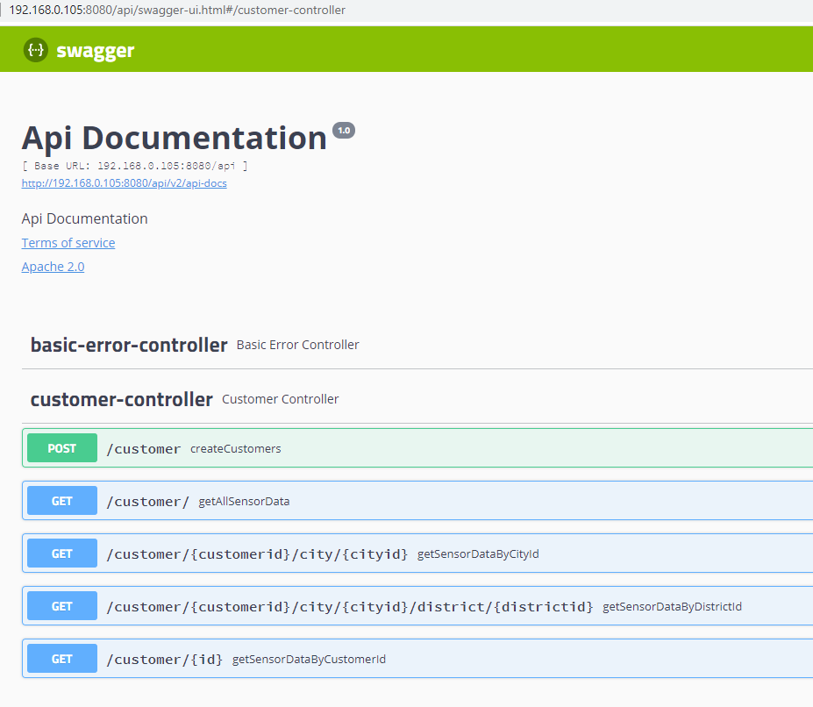

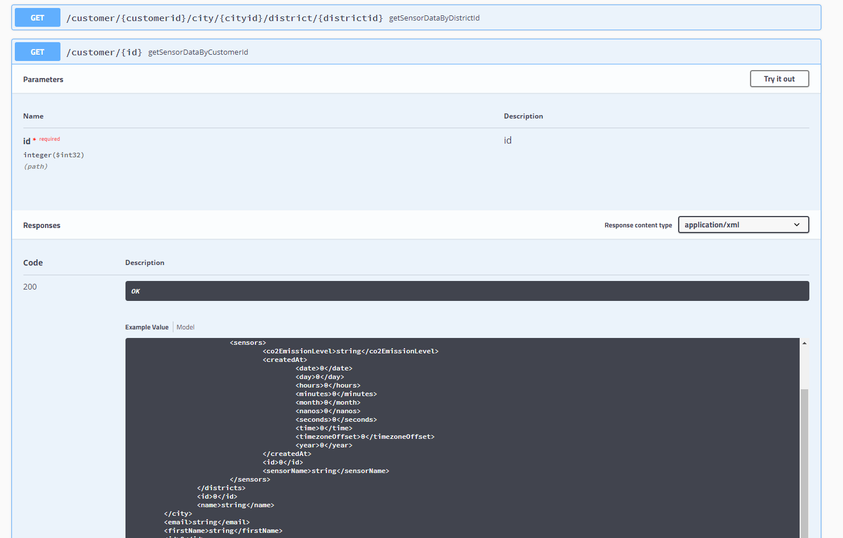

1. CO2 Sensor data application

It enables the local city hall to keep track of the levels of CO across several city districts. In order to do so, the CO2 sensors installed throughout the city to provide CO concentration readings for each district to a given endpoint of server. Each city hall can check CO concentration historical data per district. The data model is designed in order to store and provide these data effectively. A report of CO concentrations grouped by district needs to be created and save as a file. This module APIs are available in both XML and JSON format.

# API end points

|  |  |  |
| --- | --- | --- |
| **#** | **Description** | **Message URL** |
| **1** | **List of all emission details per customer(Get sensor data)** | **Eg :**  <http://localhost:8080/api/v1/>customer/sensordata |
| **2** | **List the details against a specific customer (Get sensor details by customer)** | **Eg :**  <http://localhost:8080/api/v1/customer/sensordata/customer/>{customerId} |
| **3** | **List the details against a specific city (Get sensor details by city)** | **Eg :**  <http://localhost:8080/api/v1/customer/sensordata/customer/>{customerId}/city/{cityId} |
| **4** | **List the details against a specific district (Get sensor details by district)** | **Eg :**  <http://localhost:8080/api/v1/customer/sensordata/customer/>{customerId}/city/{cityId}/district/{districtId} |
| **5** | **Save or update the customer, city, district, sensor details(Create or update by customer)** | **Eg :**  <http://localhost:8080/api/v1/>customer/sensordata/create |
| **6** | **View the endpoints and documentation in swagger UI** | **Eg:**  http://localhost:8080/api/swagger-ui.html |
| **7** | **Access to h2 DB console** | **Eg:**  http://localhost:8080/api/h2 |

# Get all Sensor data

To list all co2 emission details per customer.

URL : <http://localhost:8080/api/v1/>customer/sensordata

**Response**

**Sample Message response:**

|  |
| --- |
| <List>      <item>          <id>1</id>          <firstName>John</firstName>          <lastName>Doe</lastName>          <email>custln1@gmail.com</email>          <city>              <id>1</id>              <name>city1</name>                  <districts>                      <id>3</id>                      <name>dist3</name>                      <sensors>                          <sensors>                              <id>4</id>                              <sensorName>sensor4</sensorName>                              <co2EmissionLevel>66</co2EmissionLevel>                              <createdAt>2020-08-09 17:40:14</createdAt>                          </sensors>                          <sensors>                              <id>5</id>                              <sensorName>sensor5</sensorName>                              <co2EmissionLevel>28</co2EmissionLevel>                              <createdAt>2020-08-10 10:00:14</createdAt>                          </sensors>                          <sensors>                              <id>6</id>                              <sensorName>sensor6</sensorName>                              <co2EmissionLevel>22</co2EmissionLevel>                              <createdAt>2020-08-10 10:00:14</createdAt>                          </sensors>                      </sensors>                  </districts>              </districts>          </city>      </item>  </List> |

# Get details against a Customer

To list all details against a customer.

URL : <http://localhost:8080/api/v1/customer/sensordata/customer/>2

**Response:**

**Parameter**:

|  |  |  |  |  |
| --- | --- | --- | --- | --- |
| Parameter | Type | Description | Default | Mandatory/Optional |
| Customer_id | Integer | Unique customer id |  | Mandatory |

**Sample message response**:

|  |
| --- |
| <Customer>      <id>2</id>      <firstName>Mary</firstName>      <lastName>Kom</lastName>      <email>mary@email.com</email>      <city>          <id>2</id>          <name>city2</name>          <districts>              <districts>                  <id>5</id>                  <name>dist5</name>                  <sensors>                      <sensors>                          <id>9</id>                          <sensorName>sensor9</sensorName>                          <co2EmissionLevel>54</co2EmissionLevel>                          <createdAt>2020-08-10 10:00:14</createdAt>                      </sensors>                  </sensors>              </districts>              <districts>                  <id>6</id>                  <name>dist6</name>                  <sensors>                      <sensors>                          <id>10</id>                          <sensorName>sensor10</sensorName>                          <co2EmissionLevel>44</co2EmissionLevel>                          <createdAt>2020-08-10 10:00:14</createdAt>                      </sensors>                  </sensors>              </districts>          </districts>      </city>  </Customer> |

# Get details against a City

To list all details against a city.

URL : <http://localhost:8080/api/v1/customer/sensordata/customer/>2/city/2

**Response:**

**Parameter**:

|  |  |  |  |  |
| --- | --- | --- | --- | --- |
| Parameter | Type | Description | Default | Mandatory/Optional |
| customer_id | Integer | Unique customer id |  | Mandatory |
| city_id | Integer | Unique city id |  | Mandatory |

**Sample message response**:

|  |
| --- |
| <City>      <id>2</id>      <name>city2</name>      <districts>          <districts>              <id>5</id>              <name>dist5</name>              <sensors>                  <sensors>                      <id>9</id>                      <sensorName>sensor9</sensorName>                      <co2EmissionLevel>54</co2EmissionLevel>                      <createdAt>2020-08-10 10:00:14</createdAt>                  </sensors>              </sensors>          </districts>          <districts>              <id>6</id>              <name>dist6</name>              <sensors>                  <sensors>                      <id>10</id>                      <sensorName>sensor10</sensorName>                      <co2EmissionLevel>44</co2EmissionLevel>                      <createdAt>2020-08-10 10:00:14</createdAt>                  </sensors>              </sensors>          </districts>      </districts>  </City> |

# Get details against a District

To list all details against a district.

URL : <http://localhost:8080/api/v1/customer/sensordata/customer/>2/city/2/district/5

**Response:**

**Parameter**:

|  |  |  |  |  |
| --- | --- | --- | --- | --- |
| Parameter | Type | Description | Default | Mandatory/Optional |
| customer_id | Integer | Unique customer id |  | Mandatory |
| city_id | Integer | Unique city id |  | Mandatory |
| district_id | Integer | Unique city id |  | Mandatory |

**Sample message response**:

|  |
| --- |
| <District>      <id>5</id>      <name>dist5</name>      <sensors>          <sensors>              <id>9</id>              <sensorName>sensor9</sensorName>              <co2EmissionLevel>54</co2EmissionLevel>              <createdAt>2020-08-10 10:00:14</createdAt>          </sensors>      </sensors>  </District> |

# Create Customer

To create new customer, city, district and sensor.

URL : <http://localhost:8080/api/v1/customer/sensordata/create>

**Sample message request:**

|  |
| --- |
| <Customer>      <firstName>John</firstName>      <lastName>Snow</lastName>      <email>john@email.com</email>      <city>          <name>West</name>          <districts>              <districts>                  <name>us</name>                  <sensors>                      <sensors>                          <sensorName>us-sens1</sensorName>                          <co2EmissionLevel>54</co2EmissionLevel>                          <createdAt>2020-08-10 10:00:14</createdAt>                      </sensors>                  </sensors>              </districts>              <districts>                  <name>dist6</name>                  <sensors>                      <sensors>                          <sensorName>us-sens2</sensorName>                          <co2EmissionLevel>44</co2EmissionLevel>                          <createdAt>2020-08-10 10:00:14</createdAt>                      </sensors>                  </sensors>              </districts>          </districts>      </city>  </Customer> |

**Sample message response:**

|  |
| --- |
| <Customer>      <id>5</id>      <firstName>John</firstName>      <lastName>Snow</lastName>      <email>john@email.com</email>      <city>          <id>5</id>          <name>West</name>          <districts>              <districts>                  <id>12</id>                  <name>us</name>                  <sensors>                      <sensors>                          <id>15</id>                          <sensorName>us-sens1</sensorName>                          <co2EmissionLevel>54</co2EmissionLevel>                          <createdAt>2020-08-10 10:00:14</createdAt>                      </sensors>                  </sensors>              </districts>              <districts>                  <id>13</id>                  <name>dist6</name>                  <sensors>                      <sensors>                          <id>16</id>                          <sensorName>us-sens2</sensorName>                          <co2EmissionLevel>44</co2EmissionLevel>                          <createdAt>2020-08-10 10:00:14</createdAt>                      </sensors>                  </sensors>              </districts>          </districts>      </city>  </Customer> |

1. Technologies used

* Spring Boot
* Spring JPA
* Spring REST
* H2 Database
* JDK 1.8
* Maven
* Swagger

1. Supporting documents

* ER Diagram
* UML Diagram